Sustainable ICT for Emerging Economies Program
Mythology and Reality of the Digital Divide Problem

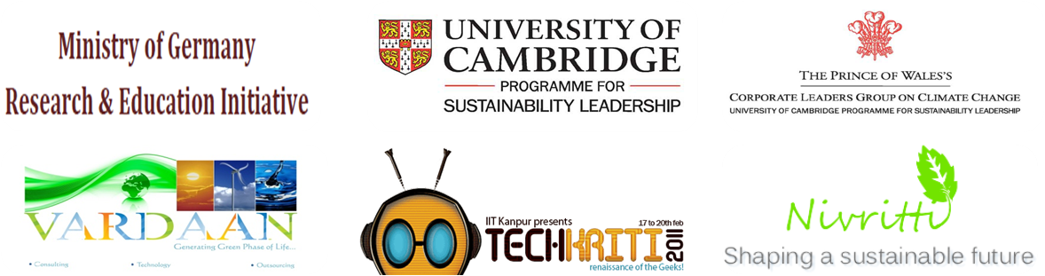
Associates / Signatories

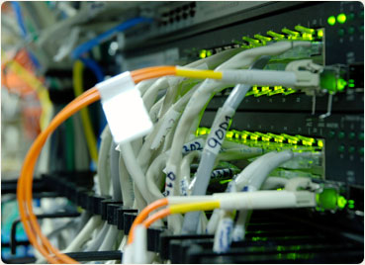
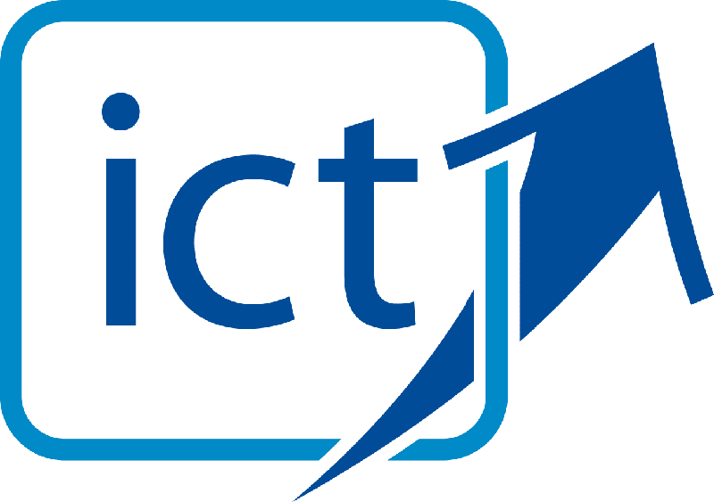
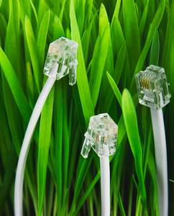

Theme#3:
ICT Innovations with R&D
National/International level
ICT & emissions
Technology innovations
“Nano” scaling
E-Governance/E-learning/E-community
Internet Technologies
Advance Systems & Network securities
Expert Systems: Modelling & Simulation
4G Technology
Neural Networks & Fuzzy Systems
Artificial Intelligence & Robotics

Theme#2:
Different aspects of ICT
Green Computing
-Cloud Computing
-Grid Computing
-Distributed computing
Communication Technology
Carbon footprints
Smart Grid Networks/Smart Utility

Theme#1:
ICT & Sustainability
Technologies
Infrastructure
Supply Chains
End Consumers

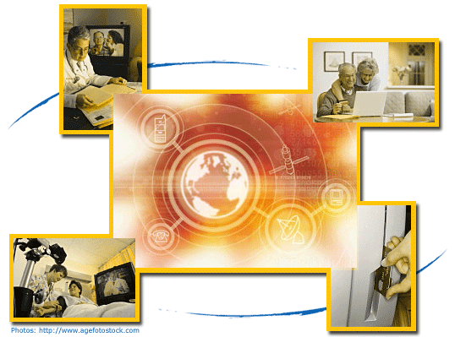
Opportunities
Government
&
PPP
Case Studies
Impacts
&
Conditions

Flow of Training Program
Introduction to ICT
Barriers
&
Solutions
Hands-on-sessions:-
Cloud Computing
Green Computing
RENET
Sap based other software
Theme#4:
Future Scopes & opportunities in renovated Green ICT
Technical point of view
Business point of view
Innovations
Jobs/Employments
Government & PPP models

Theme#5:
ICT and its Sustainable mode of application
Rural area development application
Poverty alleviation
Smart Urbanization
System transparency
Local & Global achievements
Nano Technology applications
Women empowerment & development
Biotechnology & its application in ICT

- Introduction
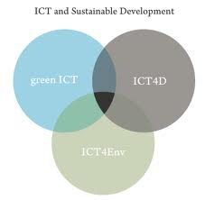
The implications of the advances in information and communication technologies (ICT) for developing economies are profound. ICT is not a cure to all the problems. However, the poor, the sick and the illiterate of the world have more to gain in relative terms than the billion people who already enjoy the benefits of this technology. ICT can be a powerful tool to facilitate and enable affordable solutions to-
- economic development
- individual development
- social development

The extent to which ICTs also affect progress towards environmental sustainability in an economy is an issue that is still under debate. There is, however, increasing evidence that significant opportunities and threats are involved as-

1. volume of transport relative to gross domestic product,
2. modal split of transport,
3. energy consumption and share of renewables,
4. greenhouse gas emissions,
5. municipal waste collected but not recycled.

These deserve more research and more attention in energy, climate change and technology policies.

- ICT applications
- ICT industry
- ICT use :
- e-business
- virtual mobility
- virtual goods
- waste management
- intelligent transport systems
- energy supply
- facility management
- production process management

- Impacts and Opportunities:
- those created by the physical existence of ICTs and the processes involved (first order effects)
- those created by the ongoing use and application of ICTs
- those created by the aggregated effects of large numbers of people using ICTs over the medium to long term

- Uncertain factors:
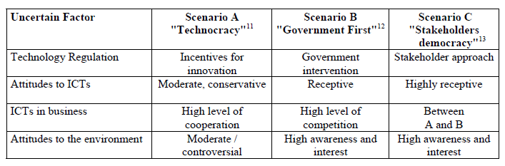

- Future Impacts of ICTS on Environmental Sustainability
- The impact on the environmental indicators
- Freight transport performance
- Passenger transport performance and modal split
- Energy Consumption and the share of renewable energy sources in electricity generation
- Greenhouse gas emissions
- Non-recycled municipal solid waste
- The impact of different ICT applications
- Areas of impact ranked by significance
- Cross-cutting issues
- The rebound effect
- Accession countries

- Recommendations & Current Status of ICT application – user interface in:
- Industry
- Transport
- Virtual Mobility
- Facility management
- Energy
- Greenhouse gas emissions
- Waste
- Cross-cutting issues
- Acceding countries
- Research and development
- Rebound effects

Barriers to Entry
The reality is that in order to make this technology truly available, accessible, and affordable, there are many technical, social, regulatory and legal issues that need to be solved. Less than 10% of technical, economic and social problems of “what it will take to fully harness the power of ICT” relate to having a PC.

It is well known that Digital Divide really consists of many sub-divides:

- Infrastructure Divide
- Access Divide
- Literacy Divide
- Language Divide
- Information and Knowledge Access Divide
- Jobs Divide
- Health-care Divide
- Entertainment Divide
- Demographic Divide

- Necessary Conditions for Sustainable/Ubiquitous ICT:
- existence of a clear value proposition
- accessibility
- affordability
- trustable and tamperproof

The 4C Research, Development, and Demonstration Testbed Agenda

The Four Columns (4Cs) that are essential to support Universal Utilization of ICT
- Connectivity
- Computer access
- Content
- Capacity building.

- Case Study: The FiberAfrica Case Study

Computer Access Case Study: PCtvt

- Appropriate infrastructure and user - devices

Capacity Building
“Give man a fish and you will feed him for a day. Teach man to fish and you will feed him for life”

Social, Regulatory and Legal Issues:
- Obstacles to the proposed vision of Free Internet - Disenfranchisement
- Current Internet Service Providers (ISPs) and incumbents.
- High costs
- High speed internet services in Emerging Economies vs Industrialized Countries.
- Tiny subscriber pool
- Limit innovation and convergence, e.g., disallowing unlicensed wireless or IP

New Roles for Providers:
Free Road System (paid for by taxes) creates the demand for cars, gasoline, motels, mechanics, auto supplies, repair shops etc. (all of which generate economic growth and jobs and, indirectly, governmental revenue from taxes),
Vs
Existence of a Free Information Highway will generate economic growth and value added taxes.
- Government Roles - Creation of fiber and wireless infrastructure
- Private sector or competitive public sector companies –
- Day-to-day operation
- Customer service
- Maintenance
- Upgrading of the infrastructure
- And many more

Business models for compensating copyright and intellectual property (IP) owners

Conclusion
Such efforts should lead to plausible solutions resulting in the availability of tools and solutions for the whole world as “open source.” Such a community would:

- Role for free or nearly free broadband Internet connectivity.
- Multi-function information appliances
- Applications and content those are primarily meant for –
- rural or disadvantaged populations
- accessible to all citizens regardless of education, status or location
- Universal access to knowledge and know-how by creating a center (a National Digital Library?)
- Develop solutions to overcome language barriers
- Establish International Fellowships - “Capacity Building in IT”

10.1 The primary issue -
- Government
- Academia,
- Industry,
- Research
- Development agencies
- Policy statements and reports

- Case Study: e-Choupal

- Challenges and problems posed by 4Cs
- Connectivity
- Computer-access
- Content
- Capacity-building

- Hand – on – session
Simulation Softwares#1 – Cloud Computing
Simulation Softwares#2 – Grid Computing
Simulation Softwares#3 – Distributed Computing
RENET Software – Canadian Ministry
Processing Software – Supply Chains, SAP etc.
Duration & Financial Details:

Total Duration: 1 day depending on depth that is to be achieved, number of modules to be covered and time available with all stakeholders

Certification: The workshop is cerfitied by:-

Signatory: Sustainable Leader Program, University of Cambridge

Partner: Ministry of Germany Research & Education Initiative

Affiliation: Ministry of New & Renewable Energy [MNRE] affiliated associates

Total Cost / Participant: INR 400 / participant for 1 day

It includes the following:-
- Practicum training charges
- Training Material (Handouts)
- Hands-on experience & take-away of the specially designed / customized international softwares / tools
- Participation Certificate (to all participants)
- An open offer for Our Re-investment programs
- Green Jobs/Internship network membership
- Future support to outstanding performers of workshop & also to college for all future sustainability related initiatives

Best Regards,
Steffen Ferrell

Co-Founder, GREEN ADD+
www.greenadd.in

Annexure – Recent Associations:

Organizations associated with Project Nivritti:

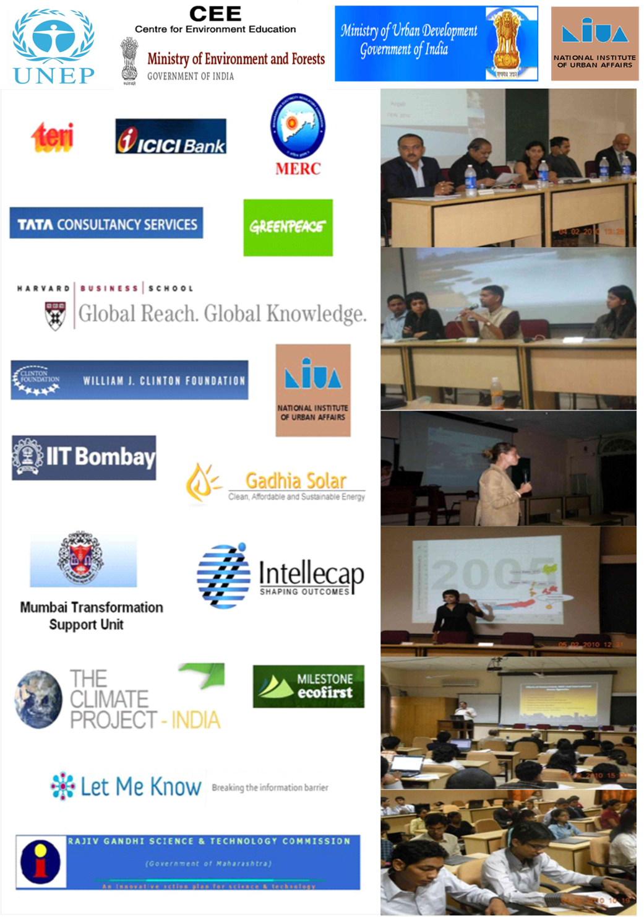

Vardaan Energy:
Vardaan Energy is officially registered under the following & one of the few companies to have got the prestigious ‘Akshaya Urja’ recognition. It is a manufacturer of Solar Modules and LEDs and has successfully implemented more than 35 projects – for both the private as well as government sector.

Some recent tie-ups / programs by GreenADD+:
Harvard Sustainability Initiative, IIT Kharaghpur, IIT Bombay, IIT Kanpur, IIT Roorkee, BITS Pilani, IT-BHU, Yuva – International Youth Summit on Climate Change, NIT Warangal, NIT Durgapur, BITS Goa, Veermata Jijabai Institute of Technology Mumbai, Amrita University Tamilnadu, Indian School of Mines Dhanbad, Saastra University Tamilnadu, Delhi College of Engineering and along with that many other Institutions and Universities across country. GREEN ADD+ is the first of its kind of organization in India which is also associating with many Corporates/NGOs/Governmental Nodal agencies in the field of Sustainable Development.

---------------------------------------

